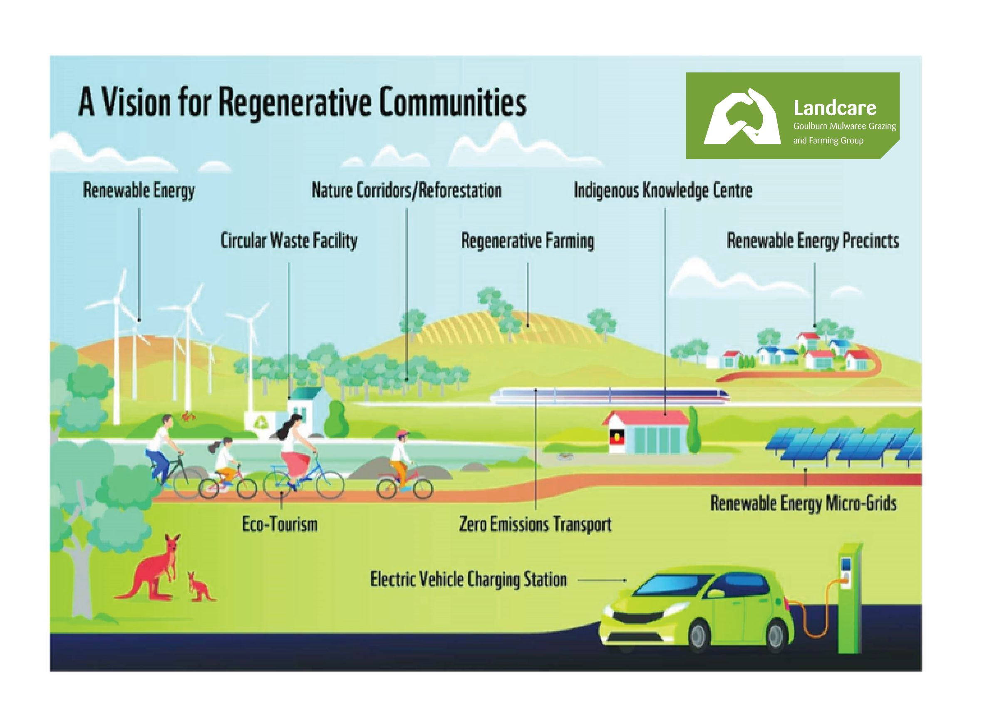

The Goulburn Mulwaree Community Sustainability Hub
Our Vision
To have a healthy, sustainable community across Goulburn Mulwaree.
Our Mission
Starting with the least advantaged, to build a sustainable community that acts together to address the challenges of the changing climate.

Bulletin:- 7-10-23
Much has happened since the announcement of the formation of the G-M Community Sustainability Hub (CSH) and a date for the initial meeting of the Steering Committee has now been scheduled, post the Voice to Parliament referendum.
Goulburn-Mulwaree Regen Ag and Landscape Regeneration Project for Youth.
The EOI for the project went in 6th October and, all things being equal, the project proposal will follow.
This opportunity comes to us from Bioregional, a member of the CSH, see:- https://www.bioregional.com/one-planet-living. The CSH incorporates On Planet Living in its framework.
Potentially this project could include the following members of the CSH and would be coordinated by the CSH:-
- Aboriginal Community
- G-M Council
- Community Voice For Hume
- Landcare G-M
- Local schools
- ZeroSE, in particular for project metrics
- Chevalier College & Regen Action as CC are running a Regen Ag project with Regen Action
- ANU – Regen Ag & Landscape regeneration, in particular bringing the two together where possible
- LLS SE NSW – collaborate around LLS’ strategic plans
- Chamber of Commerce

Other Plans and News!!
- Date of Community Sustainability Hub Steering Committee Meeting is:- 28th October, 10-3 at the Workers Club, more details to follow, including the proposed agenda. All are welcome to attend

- Eco-Tourism Part 1 – this is planned to start with Aboriginal-led tours of the Wetlands and expand from there, eg into the West Goulburn Bushland. Tours to be booked (and paid for) through the Visitor Centre and start with an overview of the Aboriginal history of the wetlands area.

- Eco-Tourism Part 2 – this will be an extension of Part 1 above and is about Sustainable Gardens and to be organised by the Visitor Centre for people outside Goulburn. Potential initial gardens could be:-

  - North Goulburn Union Street:- Natives, Vegetables and Fruit
  - West Goulburn off Wheeo Rd, flood mitigation (through water capture), native planting veggie patch, chickens and retro-fit sustainable House
  - Ducks Lane, Run-O-Waters, flood mitigation through swales, ponds and native planting, and drainage
  - Tarago – Permaculture=based plan, water capture with swales, vegetable, chickens, pigs, vegetables and fruit. Aiming at self-sufficiency on 2.5 acres
  - Crookwell ????

- Do you have such a garden to show others?

- Be Part of The first Neighbourhood Garden Action Group - The neighbourhood in question is North Goulburn centred around Union Street. The group is led by Cindy who, together with her gardener, has built a sustainable fruit and vegetable garden. You are also invited to attend if you are inter and has been improving the sustainability of her house. Please also attend if you are interested in starting your wn group. Register your interest on this link:- https://console.humanitix.com/console/my-events/65221edb70884dfc0905364d/info/basics

- Meeting Held With Wendy Tuckerman State MP accompanied by Cindy Dolan, to brief her about the CSH.

- Significant grants for Community Groups have been announced that could be pertinent and are around $500k

- The G-M Landcare Group, now a separately incorporated body, will be working closely with the G-M CSH on building local food sufficiency

- Bob attended an open meeting of the Chamber of Commerce and that has led to establishing a relationship with the group’s Vice President that will assist with the to promote Goulburn-Mulwaree Regen Ag and Landscape Regeneration Project for Youth to the G-M Council, already covered in this newsletter.

Efforts to organise a visit to Bega Circular Valley still in-train and maybe more likely if organised by the Chamber of Commerce?

- Goulburn Crookwell Rail Trail – this is another tourist opportunity that would for in with the eco theme that will be, as far as possible Aboriginal-led and bring in the Aboriginal history of the area. See:- https://m.facebook.com/jo.haylen/videos/goulburn-to-crookwell-rail-trail/1624278464369229/

- G-M CSH Website and Fb Group being organised, so stay tuned

- Sustainability Conference and Expo – This is a major event and it is planned to run in spring or autumn that is designed to promote G-M and surrounds and to attract new talent based on the development of:-
  - Sustainable Living
  - Sustainable Businesses
  - Eco-tourism
  - Regenerative Agriculture
  - Sustainable Housing Development
  - Centre for Sustainability Research
  - Documented Carbon Sequestration
  - Council Sustainability Projects

